Hexagonal Prism
# Source: AI Source: Provided by: [Data Path: Persons Table -> ID Column: 1, Name_En Column: Motasem Essam] -> From: [ChatGPT] on [7/25/2026]
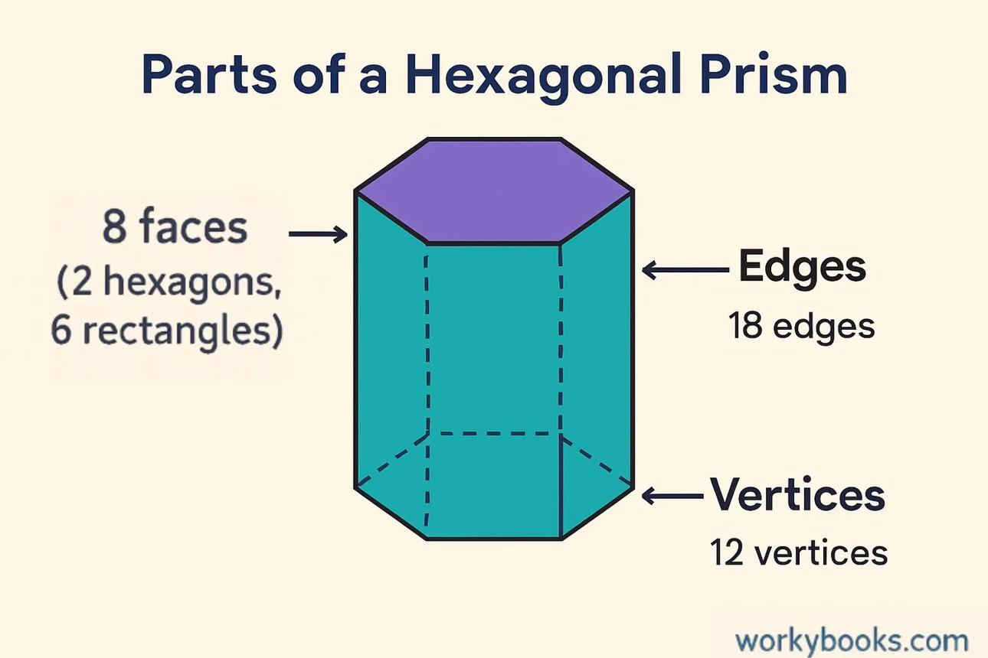
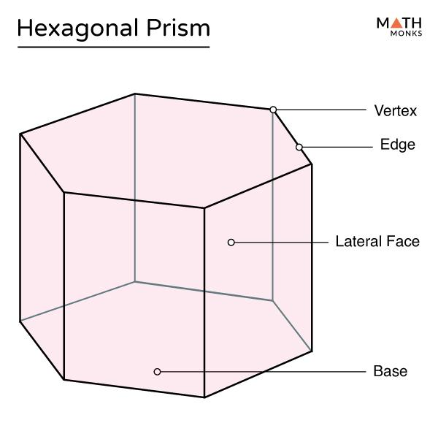
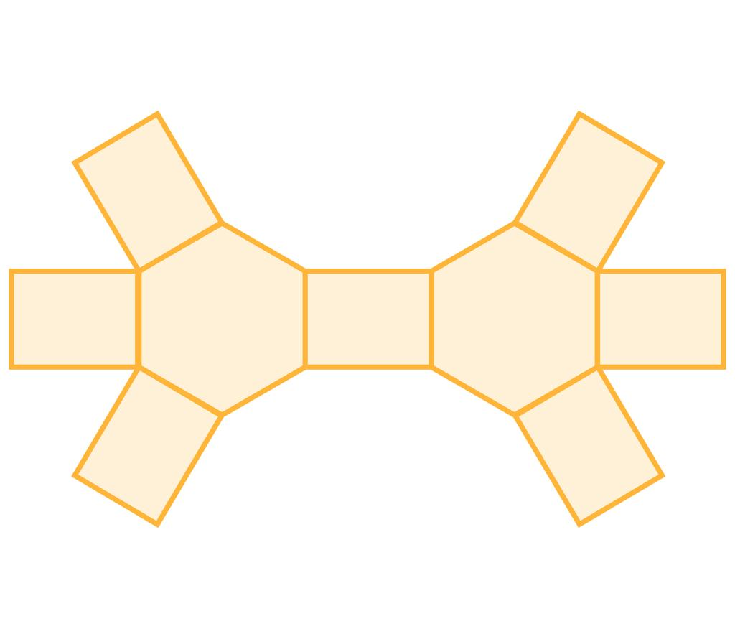

Definition
# Source: AI Source: Provided by: [Data Path: Persons Table -> ID Column: 1, Name_En Column: Motasem Essam] -> From: [ChatGPT] on [7/25/2026]
A hexagonal prism is a three-dimensional polyhedron with two congruent, parallel hexagonal bases connected by six lateral faces.
Each hexagonal base has six sides and six vertices. The six lateral faces connect corresponding edges of the two bases, forming a closed solid.
A right hexagonal prism has lateral edges perpendicular to the bases and rectangular lateral faces. An oblique hexagonal prism has inclined lateral edges and parallelogram lateral faces.

Simple Definition
# Source: AI Source: Provided by: [Data Path: Persons Table -> ID Column: 1, Name_En Column: Motasem Essam] -> From: [ChatGPT] on [7/25/2026]
A hexagonal prism is a solid shape with two identical hexagons at opposite ends and six side faces.

Classification Tree
# Source: AI Source: Provided by: [Data Path: Persons Table -> ID Column: 1, Name_En Column: Motasem Essam] -> From: [ChatGPT] on [7/25/2026]
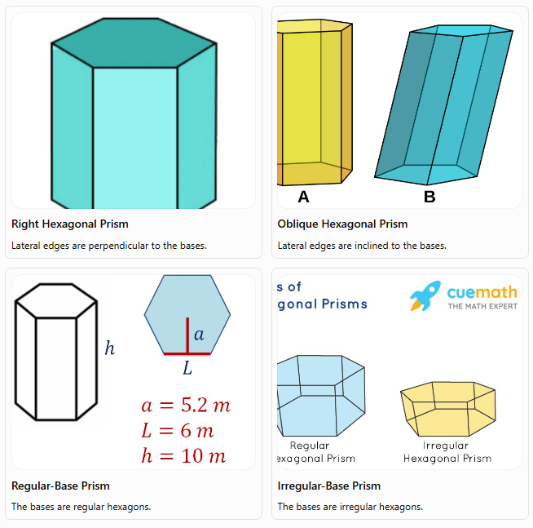
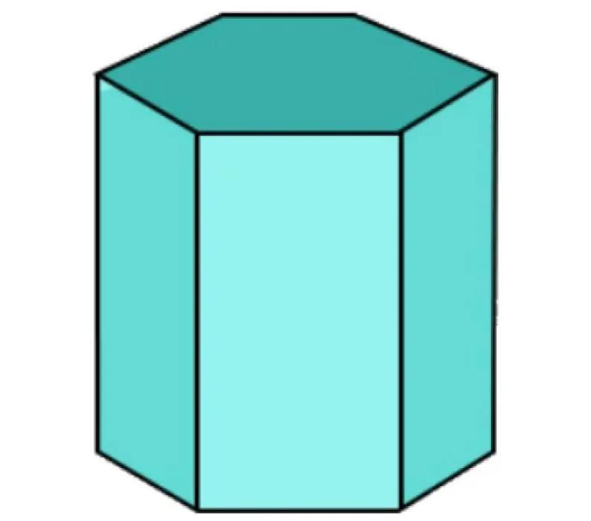
Right Hexagonal Prism
Lateral edges are perpendicular to the bases.
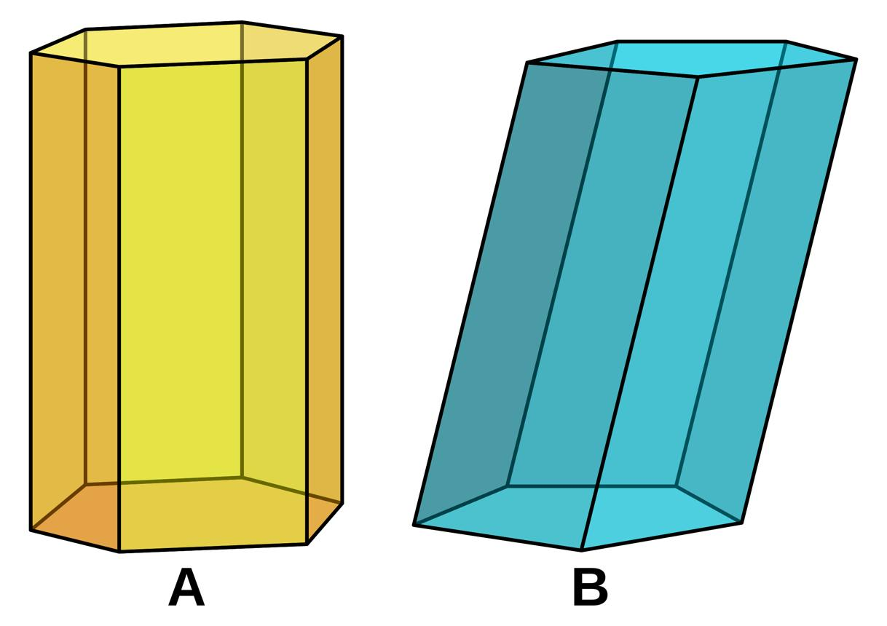
Oblique Hexagonal Prism
Lateral edges are inclined to the bases.
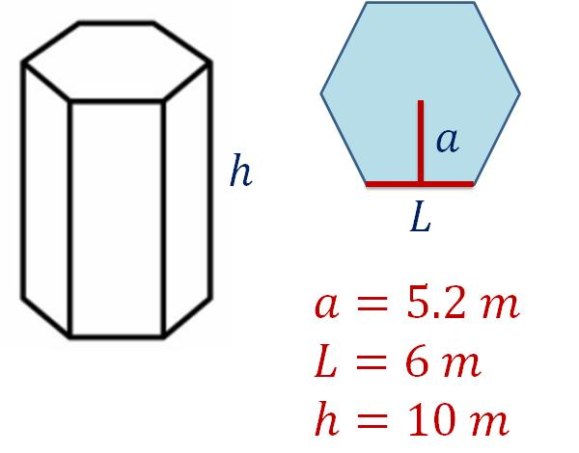
Regular-Base Prism
The bases are regular hexagons.
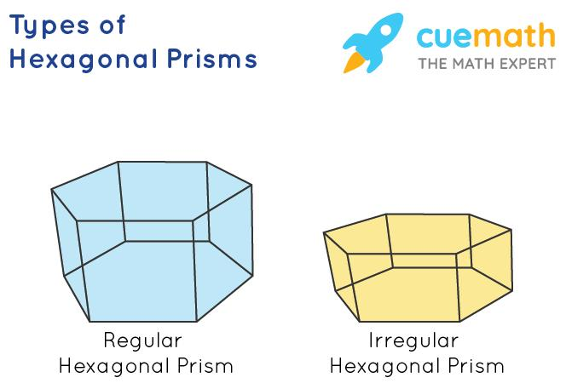
Irregular-Base Prism
The bases are irregular hexagons.
These classifications describe different properties. For example, a prism can be both right and regular-base. A regular hexagonal prism conventionally has regular hexagonal bases and perpendicular lateral edges.

Key Characteristics
# Source: AI Source: Provided by: [Data Path: Persons Table -> ID Column: 1, Name_En Column: Motasem Essam] -> From: [ChatGPT] on [7/25/2026]
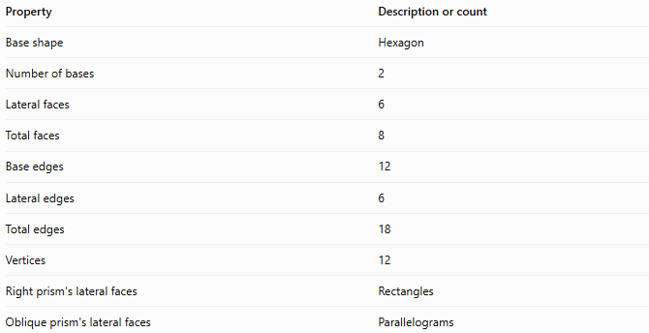
Property | Description or count
Base shape | Hexagon
Number of bases | 2
Lateral faces | 6
Total faces | 8
Base edges | 12
Lateral edges | 6
Total edges | 18
Vertices | 12
Right prism's lateral faces | Rectangles
Oblique prism's lateral faces | Parallelograms

Geometric Representation
# Source: AI Source: Provided by: [Data Path: Persons Table -> ID Column: 1, Name_En Column: Motasem Essam] -> From: [ChatGPT] on [7/25/2026]
The main components of a hexagonal prism are:
- Hexagonal bases: The two congruent, parallel hexagons.
- Lateral faces: The six faces connecting the bases.
- Base edges: The twelve edges around the two hexagonal bases.
- Lateral edges: The six edges joining corresponding vertices of the bases.
- Vertices: The twelve corner points of the solid.
- Height: The perpendicular distance between the two base planes.

Mathematical Representations and Formulas
# Source: AI Source: Provided by: [Data Path: Persons Table -> ID Column: 1, Name_En Column: Motasem Essam] -> From: [ChatGPT] on [7/25/2026]
Let:
- $B$ = area of one hexagonal base
- $p$ = perimeter of one base
- $h$ = perpendicular height of the prism
- $a$ = side length of a regular hexagonal base
- $r$ = apothem of a regular hexagonal base

A. Number of faces, edges, and vertices
# Source: AI Source: Provided by: [Data Path: Persons Table -> ID Column: 1, Name_En Column: Motasem Essam] -> From: [ChatGPT] on [7/25/2026]
For a prism with an $n$-sided polygon as its base:
$$F=n+2, E=3n, V=2n$$
For a hexagonal prism, $n=6$:
$$F=6+2=\boxed{8}$$
$$E=3\left(6\right)=\boxed{18}$$
$$V=2\left(6\right)=\boxed{12}$$

B. Area of a regular hexagonal base
# Source: AI Source: Provided by: [Data Path: Persons Table -> ID Column: 1, Name_En Column: Motasem Essam] -> From: [ChatGPT] on [7/25/2026]
For a regular hexagon with side length $a$:
$$\boxed{B=\frac{3\sqrt{3}}{2}a^{2}}$$
Its perimeter is:
$$\boxed{p=6a}$$
Alternatively, using the apothem:
$$\boxed{B=\frac{1}{2}pr}$$
For a regular hexagon, the apothem is:
$$r=\frac{\sqrt{3}}{2}a$$

C. Volume
# Source: AI Source: Provided by: [Data Path: Persons Table -> ID Column: 1, Name_En Column: Motasem Essam] -> From: [ChatGPT] on [7/25/2026]
The volume of any prism is its base area multiplied by its perpendicular height:
$$\boxed{V=Bh}$$
For a regular hexagonal prism:
$$\boxed{V=\frac{3\sqrt{3}}{2}a^{2}h}$$

D. Lateral surface area
# Source: AI Source: Provided by: [Data Path: Persons Table -> ID Column: 1, Name_En Column: Motasem Essam] -> From: [ChatGPT] on [7/25/2026]
For a right hexagonal prism:
$$\boxed{A_{L}=ph}$$
Since $p=6a$ for a regular hexagon:
$$\boxed{A_{L}=6ah}$$
For an oblique prism, add the actual areas of its six lateral parallelograms.

E. Total surface area
# Source: AI Source: Provided by: [Data Path: Persons Table -> ID Column: 1, Name_En Column: Motasem Essam] -> From: [ChatGPT] on [7/25/2026]
The total surface area includes the six lateral faces and both bases:
$$\boxed{A_{T}=A_{L}+2B}$$
For a regular right hexagonal prism:
$$\boxed{A_{T}=6ah+3\sqrt{3}a^{2}}$$

Worked Examples
# Source: AI Source: Provided by: [Data Path: Persons Table -> ID Column: 1, Name_En Column: Motasem Essam] -> From: [ChatGPT] on [7/25/2026]
Example 1: Counting faces, edges, and vertices
Problem: Find the number of faces, edges, and vertices of a hexagonal prism.
Solution:
The base is a hexagon, so $n=6$.
$$F=n+2=6+2=\boxed{8}$$
$$E=3n=3\left(6\right)=\boxed{18}$$
$$V=2n=2\left(6\right)=\boxed{12}$$
Answer: The prism has 8 faces, 18 edges, and 12 vertices.
Example 2: Calculating the volume
Problem: A hexagonal prism has a base area of $54{\text{ cm}}^{2}$ and a perpendicular height of $10\text{ cm}$. Find its volume.
Solution:
$$V=Bh$$
Substitute the given values:
$$V=54×10$$
$$\boxed{V=540{\text{ cm}}^{3}}$$
Answer: $540{\text{ cm}}^{3}$.
Example 3: Calculating the area of a regular hexagonal base
Problem: A regular hexagonal prism has a base side length of $4\text{ cm}$. Find the area of one base.
Solution:
Use the regular hexagon area formula:
$$B=\frac{3\sqrt{3}}{2}a^{2}$$
Substitute $a=4$:
$$B=\frac{3\sqrt{3}}{2}{\left(4\right)}^{2}$$
$$B=24\sqrt{3}$$
$$\boxed{B≈41.57{\text{ cm}}^{2}}$$
Answer: Approximately $41.57{\text{ cm}}^{2}$.
Example 4: Calculating total surface area
Problem: A regular right hexagonal prism has a side length of $3\text{ cm}$ and a height of $8\text{ cm}$. Find its total surface area.
Step 1: Calculate the base perimeter.
$$p=6a=6\left(3\right)=18\text{ cm}$$
Step 2: Calculate the lateral surface area.
$$A_{L}=ph=18\left(8\right)=144{\text{ cm}}^{2}$$
Step 3: Calculate the area of one base.
$$B=\frac{3\sqrt{3}}{2}{\left(3\right)}^{2}$$
$$B=\frac{27\sqrt{3}}{2}{\text{ cm}}^{2}$$
Step 4: Calculate the total surface area.
$$A_{T}=A_{L}+2B$$
$$A_{T}=144+27\sqrt{3}$$
$$\boxed{A_{T}≈190.77{\text{ cm}}^{2}}$$
Answer: Approximately $190.77{\text{ cm}}^{2}$.
Example 5: Verifying Euler's formula
Euler's formula for a convex polyhedron is:
$$V-E+F=2$$
For a hexagonal prism:
$$12-18+8=2$$
$$\boxed{2=2}$$
Therefore, the hexagonal prism satisfies Euler's formula.

Comparison with Related Prisms
# Source: AI Source: Provided by: [Data Path: Persons Table -> ID Column: 1, Name_En Column: Motasem Essam] -> From: [ChatGPT] on [7/25/2026]
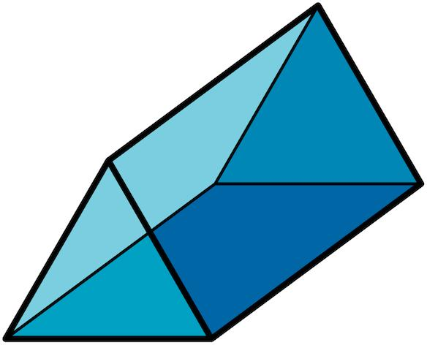
Triangular Prism
Triangular bases; 5 faces, 9 edges, and 6 vertices.
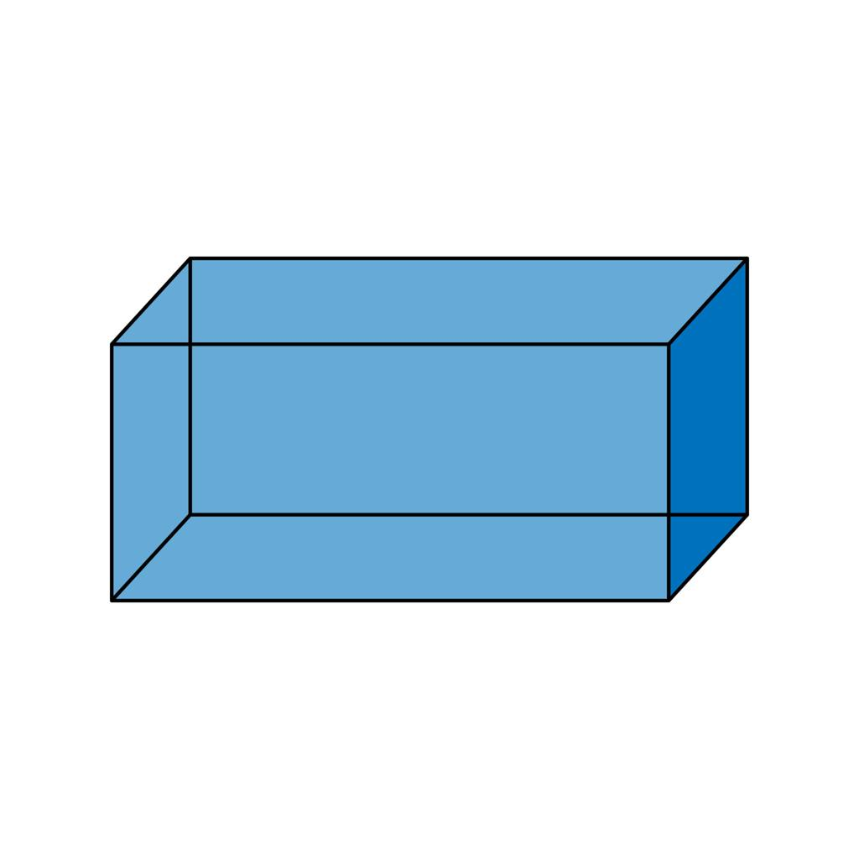
Quadrilateral Prism
Quadrilateral bases; 6 faces, 12 edges, and 8 vertices.
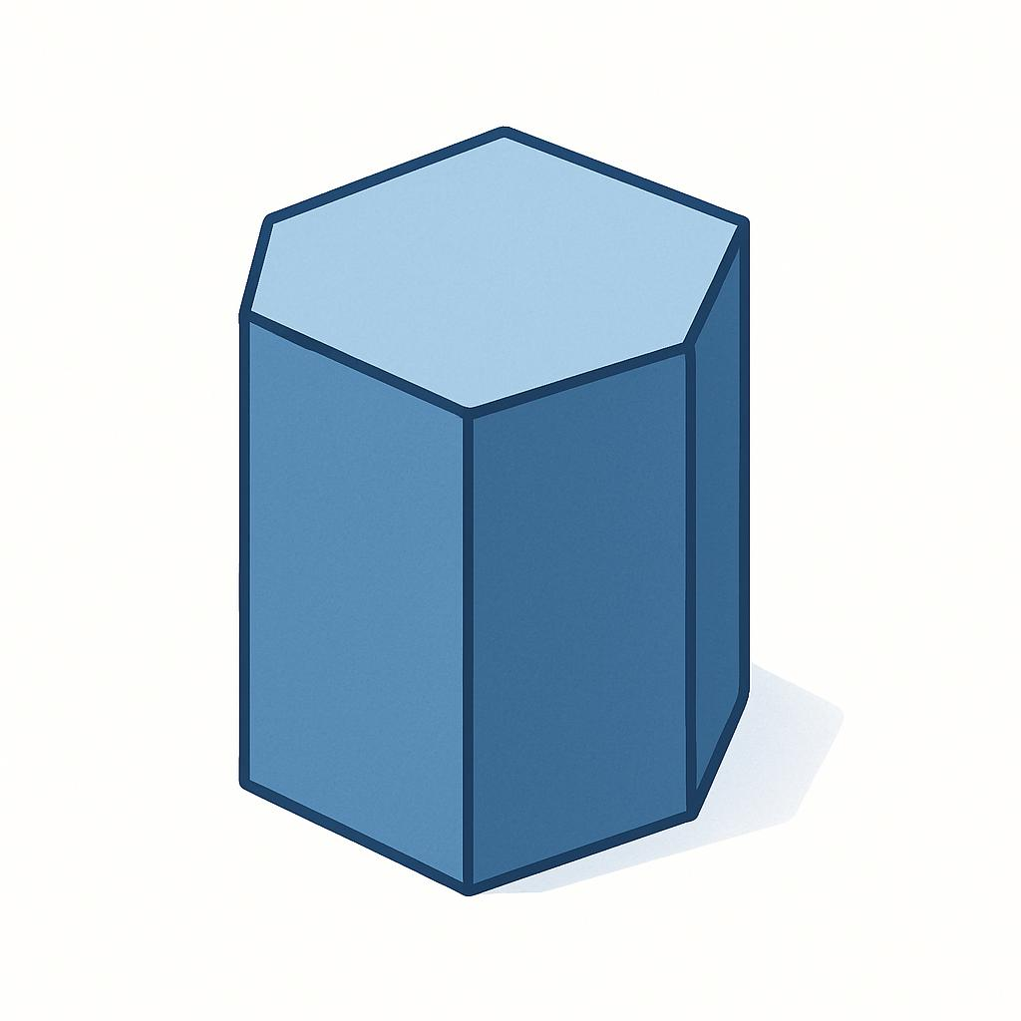
Pentagonal Prism
Pentagonal bases; 7 faces, 15 edges, and 10 vertices.
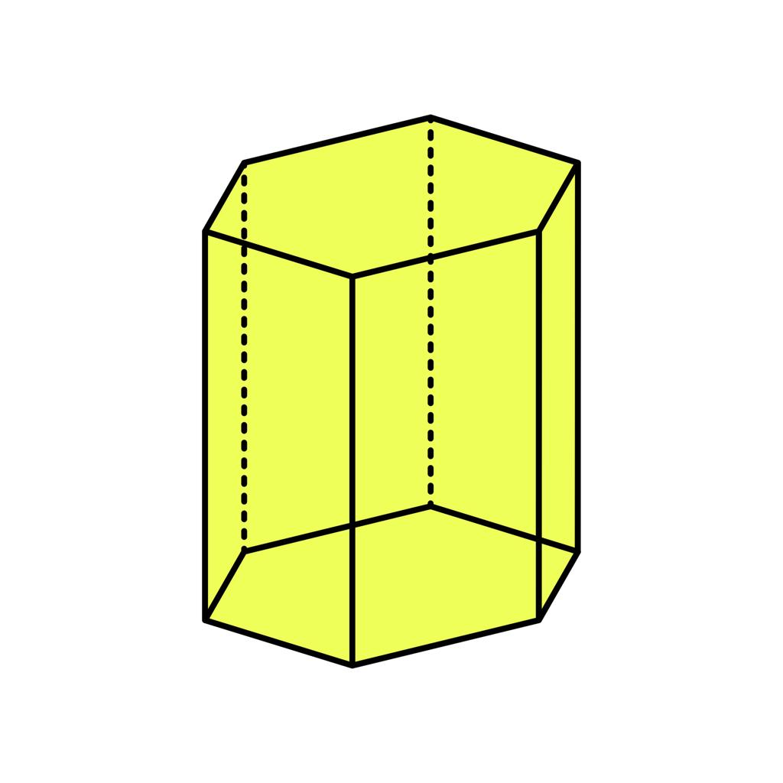
Hexagonal Prism
Hexagonal bases; 8 faces, 18 edges, and 12 vertices.
As the number of sides of the polygonal base increases by one, the prism gains one lateral face, three edges, and two vertices.

Constructing Hexagonal Prism in Solid Geometry

Instruments Used
# Source: AI Source: Provided by: [Data Path: Persons Table -> ID Column: 1, Name_En Column: Motasem Essam] -> From: [ChatGPT] on [7/25/2026]
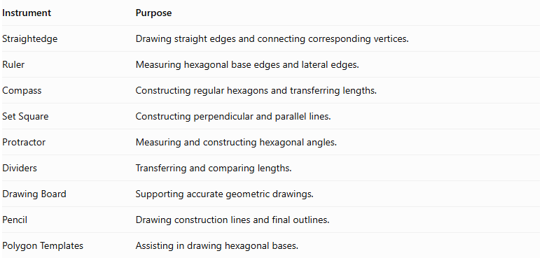
Instrument | Purpose
Straightedge | Drawing straight edges and connecting corresponding vertices.
Ruler | Measuring hexagonal base edges and lateral edges.
Compass | Constructing regular hexagons and transferring lengths.
Set Square | Constructing perpendicular and parallel lines.
Protractor | Measuring and constructing hexagonal angles.
Dividers | Transferring and comparing lengths.
Drawing Board | Supporting accurate geometric drawings.
Pencil | Drawing construction lines and final outlines.
Polygon Templates | Assisting in drawing hexagonal bases.

Construction Procedures

Constructing a Right Hexagonal Prism
# Source: AI Source: Provided by: [Data Path: Persons Table -> ID Column: 1, Name_En Column: Motasem Essam] -> From: [ChatGPT] on [7/25/2026]
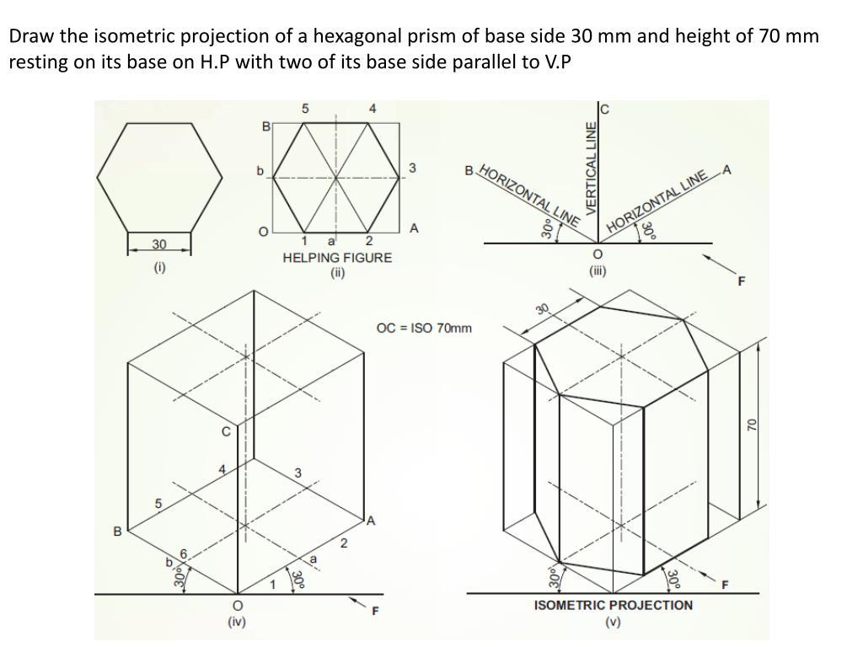
- Construct the first hexagonal base using suitable geometric instruments.
- Determine the required perpendicular height of the prism.
- Construct a second congruent hexagon parallel to the first base.
- Align the corresponding vertices along perpendicular lateral edges.
- Connect the corresponding vertices using straight lines.
- Complete the six rectangular lateral faces.
- Darken the visible edges and represent hidden edges with dashed lines when necessary.

Constructing an Oblique Hexagonal Prism
# Source: AI Source: Provided by: [Data Path: Persons Table -> ID Column: 1, Name_En Column: Motasem Essam] -> From: [ChatGPT] on [7/25/2026]
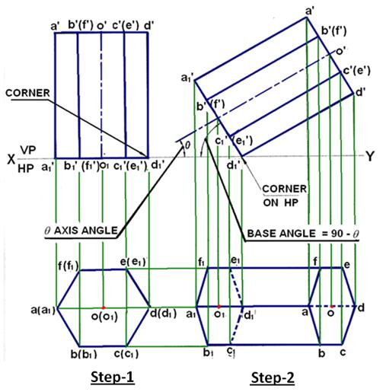
- Construct the first hexagonal base.
- Determine the required lateral-edge direction and length.
- Construct a second congruent hexagon in a parallel plane, displaced in the intended inclined direction.
- Connect corresponding vertices using parallel and equal lateral edges.
- Complete the six lateral parallelogram faces.
- Distinguish visible and hidden edges.

Constructing a Hexagonal Prism from a Net
# Source: AI Source: Provided by: [Data Path: Persons Table -> ID Column: 1, Name_En Column: Motasem Essam] -> From: [ChatGPT] on [7/25/2026]
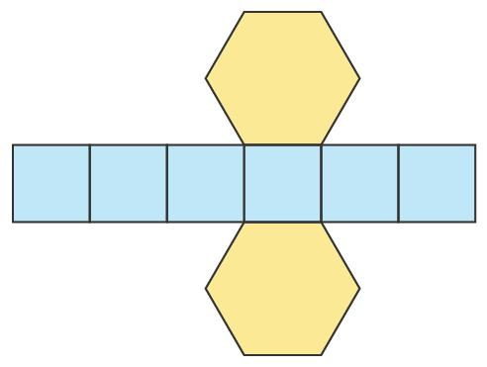
- Draw two congruent hexagonal bases.
- Construct six rectangles or parallelograms, depending on the intended prism.
- Attach each lateral face to its corresponding hexagonal base edge.
- Arrange the faces into a connected net.
- Cut out the net when constructing a physical model.
- Fold along the lateral edges.
- Join the corresponding boundary edges to form the hexagonal prism.

Constructing a Hexagonal Prism by Extrusion
# Source: AI Source: Provided by: [Data Path: Persons Table -> ID Column: 1, Name_En Column: Motasem Essam] -> From: [ChatGPT] on [7/25/2026]
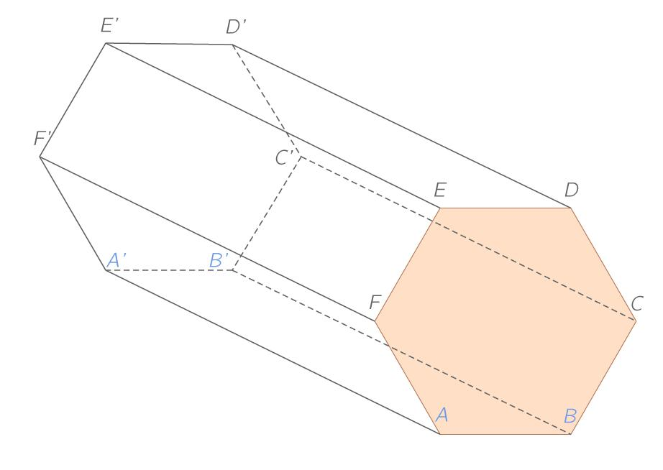
- Construct a hexagonal base.
- Establish the direction of translation.
- Transfer the hexagon along that direction while preserving its shape and dimensions.
- Connect the six corresponding vertices.
- Complete the lateral faces.

Applications of Hexagonal Prisms
# Source: AI Source: Provided by: [Data Path: Persons Table -> ID Column: 1, Name_En Column: Motasem Essam] -> From: [ChatGPT] on [7/25/2026]
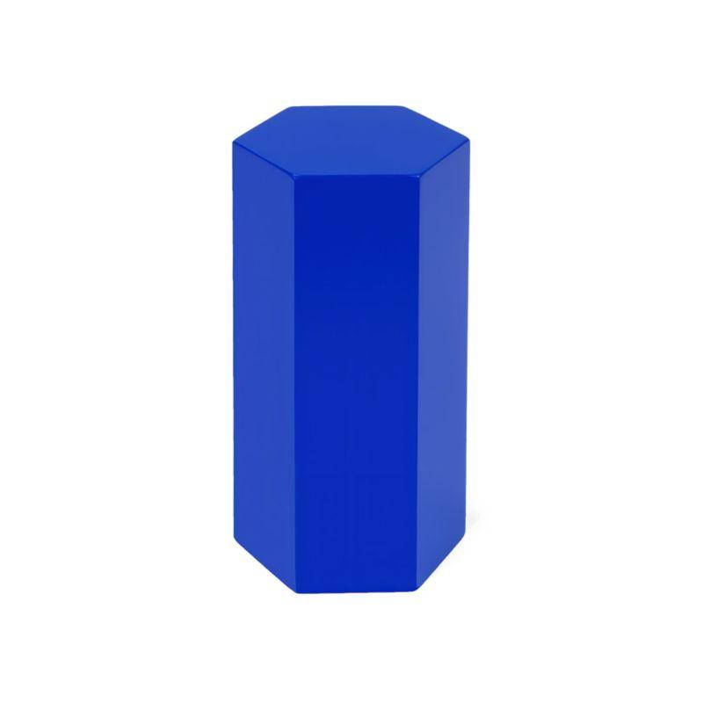
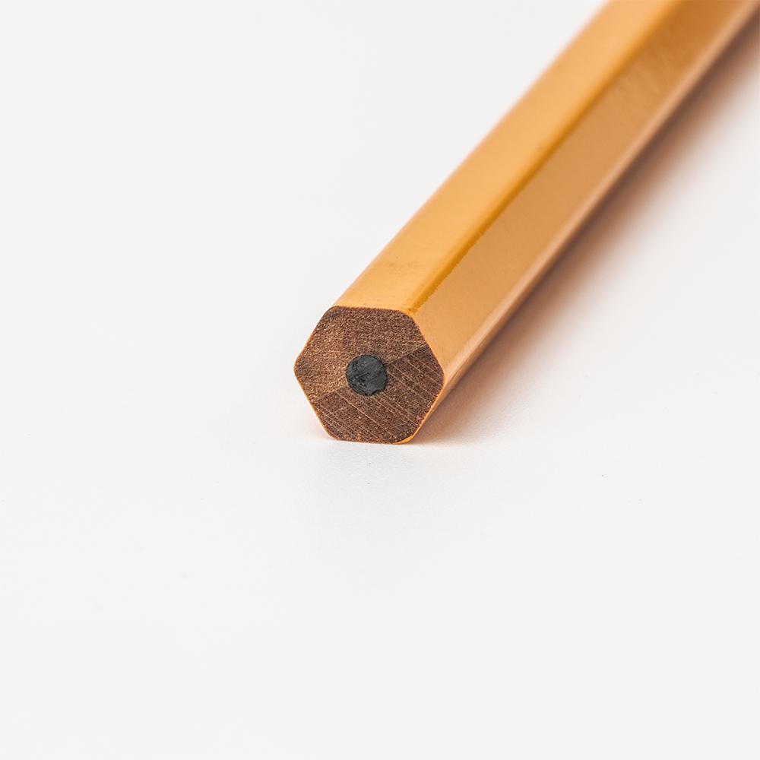
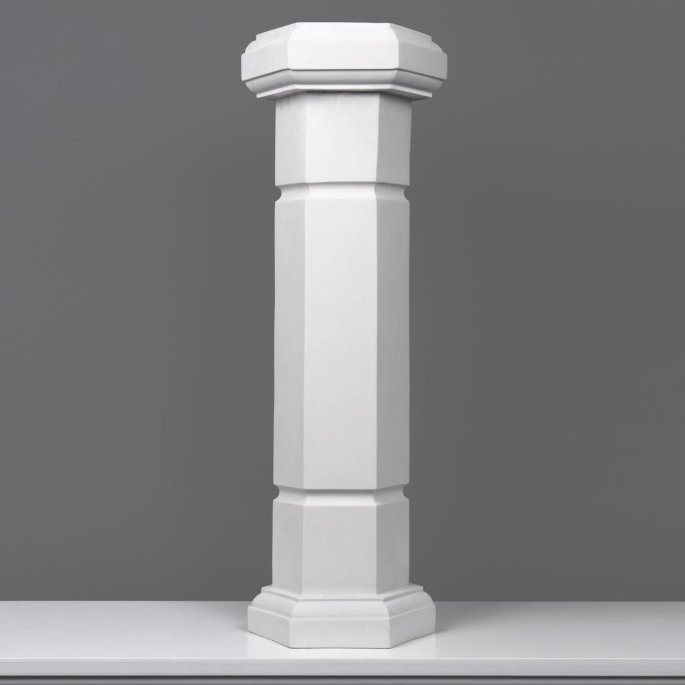
Hexagonal prisms appear in several practical settings:
- Pencils: Many pencils have a hexagonal cross-section, although their full length and pointed ends do not necessarily form a perfect hexagonal prism.
- Architecture: Hexagonal columns and structural components can use prism-like designs.
- Engineering: Hexagonal components can be modeled using prism geometry.
- Education: Hexagonal prisms help demonstrate faces, edges, vertices, surface area, and volume.
- Computer graphics: Hexagonal prisms are used to represent three-dimensional polygonal objects.

Key Points
# Source: AI Source: Provided by: [Data Path: Persons Table -> ID Column: 1, Name_En Column: Motasem Essam] -> From: [ChatGPT] on [7/25/2026]
- A hexagonal prism has two congruent, parallel hexagonal bases.
- It has six lateral faces and eight faces in total.
- It has 18 edges and 12 vertices.
- Its volume is $V=Bh$.
- For a right prism, its lateral surface area is $A_{L}=ph$.
- Its total surface area is $A_{T}=A_{L}+2B$.
- The area of a regular hexagonal base is $B=\frac{3\sqrt{3}}{2}a^{2}$.
- It satisfies Euler's formula $V-E+F=2$.

Conclusion
# Source: AI Source: Provided by: [Data Path: Persons Table -> ID Column: 1, Name_En Column: Motasem Essam] -> From: [ChatGPT] on [7/25/2026]
A hexagonal prism is a polyhedron with two congruent, parallel hexagonal bases joined by six lateral faces. It has eight faces, eighteen edges, and twelve vertices, making it a useful example of a prism with a six-sided polygonal base.
Its volume is calculated by multiplying the base area by the perpendicular height, while its total surface area is the sum of the lateral surface area and the areas of both bases. For a regular hexagonal prism, the base area can be calculated directly from its side length using \(B=\frac{3\sqrt3}{2}a^2\).
Understanding the hexagonal prism extends the general rules for polygonal prisms and helps explain how the number of sides of a base determines a solid's faces, edges, and vertices.

